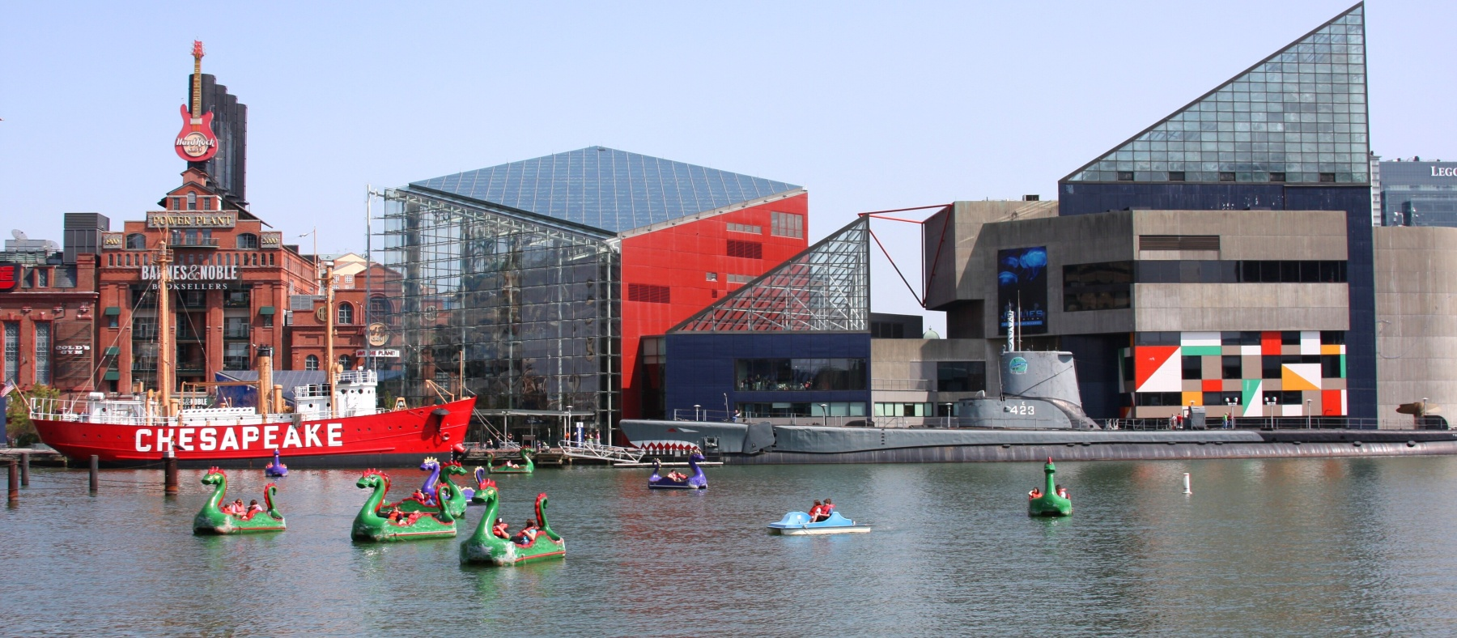
St. Francis of Assisi
Summer Camp 2017

This year’s theme:
“Oh the places we’ll go”
(Based on the Dr. Seuss story while exploring attractions in and around Baltimore!)
Hours: Care available 7am-6pm
Rate: $180 per week, full time
$50 per full day, $30 per morning (7am-11am)
**All fees must be paid through FACTS and will be due the week prior to your child attending. For example, if your child will attend camp the week of June 12th, tuition for that week will be due the week of June 5th. **
Ages: SFA Enrolled students, 2years – entering 1st grade
Weekly themes, arts and crafts, special events, cooking activities, water play, and more!
Morning and afternoon snack provided.
$40 registration fee required for each student – paid thru FACTS (send no money now).
------------------------------------------------------------------------------------------------
Name: _______________________________________ Age: ______
Grade (fall 2017 - please circle): PK2s PK3s PK3/4s PK4s K 1st
Week: | Days of Attendance: (please circle for accurate billing)
June 12-16 | Full Week OR M T W Th F | Full Day or Part Day
June 19-23 | Full Week OR M T W Th F | Full Day or Part Day
June 26-30 | Full Week OR M T W Th F | Full Day or Part Day
July 3-7, CLOSED 7/4 | Full Week OR M T W Th F | Full Day or Part Day
July 10-14 | Full Week OR M T W Th F | Full Day or Part Day
July 17-21 | Full Week OR M T W Th F | Full Day or Part Day
July 24-28 | Full Week OR M T W Th F | Full Day or Part Day
July 31- Aug 4 | Full Week OR M T W Th F | Full Day or Part Day
August 7-11 | Full Week OR M T W Th F | Full Day or Part Day
August 14-18 | Full Week OR M T W Th F | Full Day or Part Day
August 21-24, CLOSED 8/25 | Full Week OR M T W Th F | Full Day or Part Day

